Test Case: tc005_SPX_Dev5_Crear_Requisicion_Spot_Con_FAD_Tipo_Cobro_Project
Step 1 - Enter username and password and click to button Enter: Credentials Entered
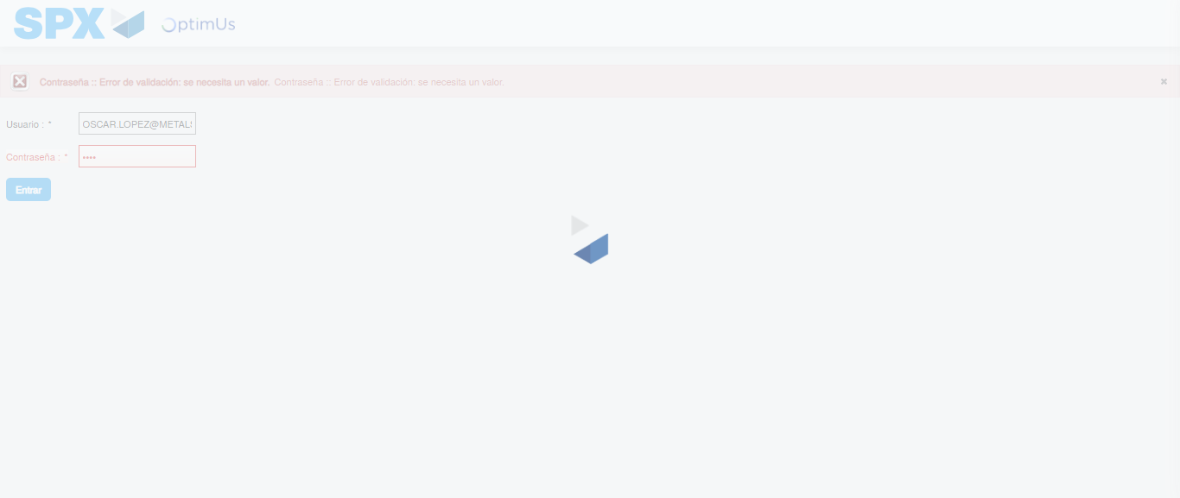Image file-name: QC_Testing-tc005_SPX_Dev5_Crear_Requisicion_Spot_Con_FAD_Tipo_Cobro_Project-1784652835959

Step 2 - Select to UEN and Access to Spot Buy Requisitions : UEN Correctly selected and Correct access
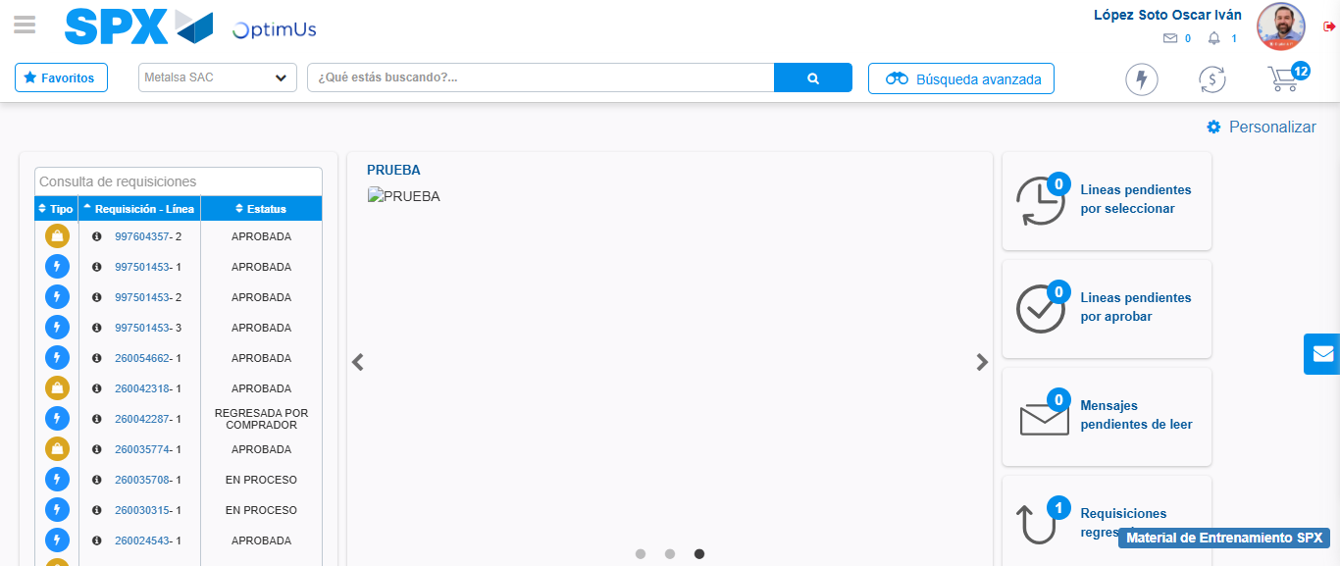Image file-name: QC_Testing-tc005_SPX_Dev5_Crear_Requisicion_Spot_Con_FAD_Tipo_Cobro_Project-1784652907986

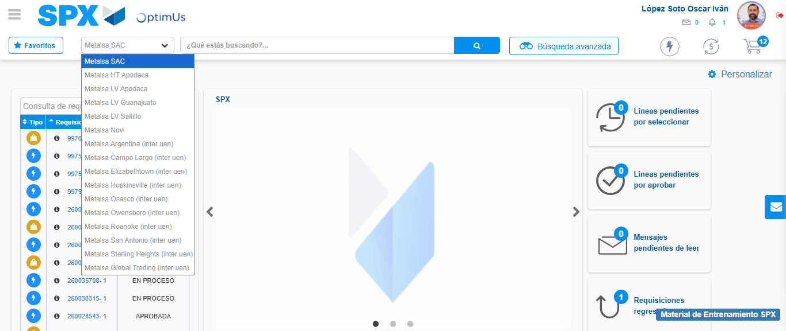Image file-name: QC_Testing-tc005_SPX_Dev5_Crear_Requisicion_Spot_Con_FAD_Tipo_Cobro_Project-1784652910732

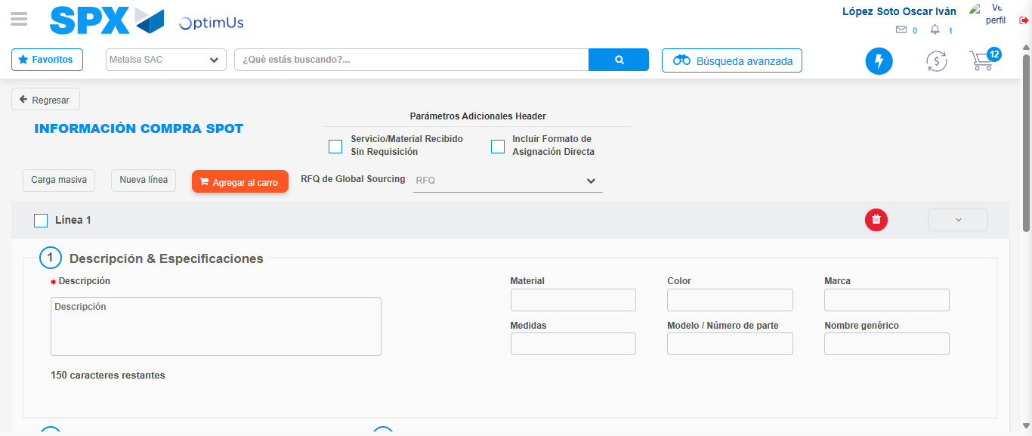Image file-name: QC_Testing-tc005_SPX_Dev5_Crear_Requisicion_Spot_Con_FAD_Tipo_Cobro_Project-1784652918197

Step 3 - Add FAD to Requisition: FAD Successfully Added
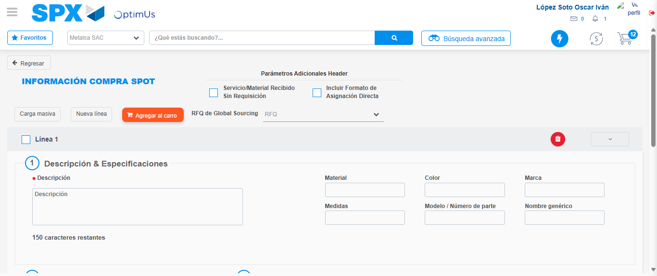Image file-name: QC_Testing-tc005_SPX_Dev5_Crear_Requisicion_Spot_Con_FAD_Tipo_Cobro_Project-1784652918536

Image file-name: QC_Testing-tc005_SPX_Dev5_Crear_Requisicion_Spot_Con_FAD_Tipo_Cobro_Project-1784652918738

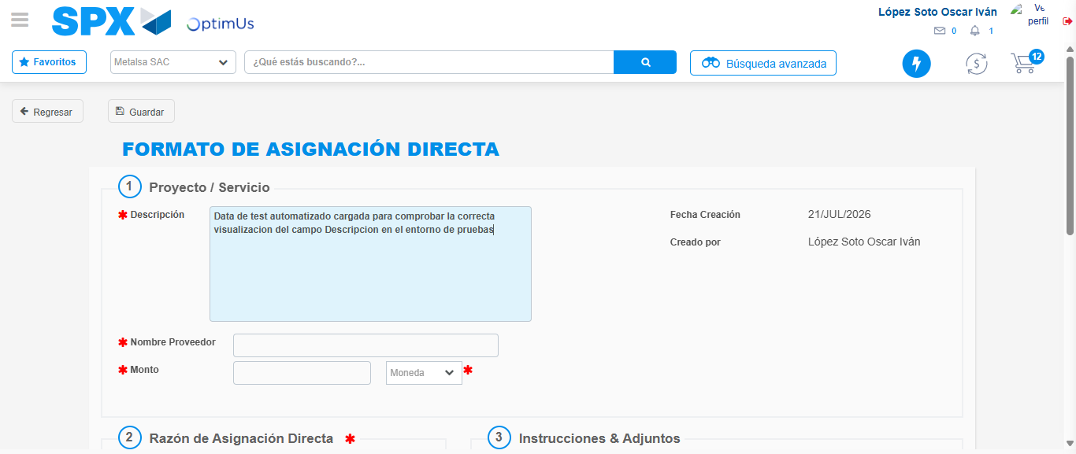Image file-name: QC_Testing-tc005_SPX_Dev5_Crear_Requisicion_Spot_Con_FAD_Tipo_Cobro_Project-1784652921866

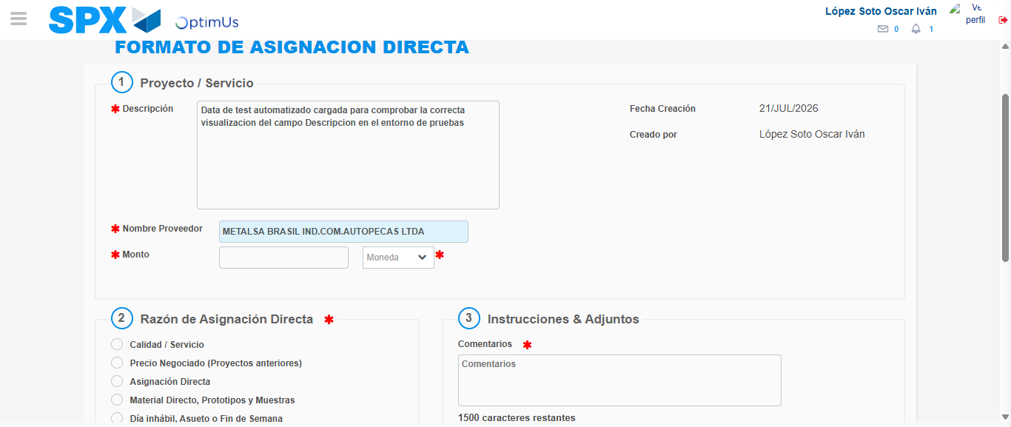Image file-name: QC_Testing-tc005_SPX_Dev5_Crear_Requisicion_Spot_Con_FAD_Tipo_Cobro_Project-1784652928667

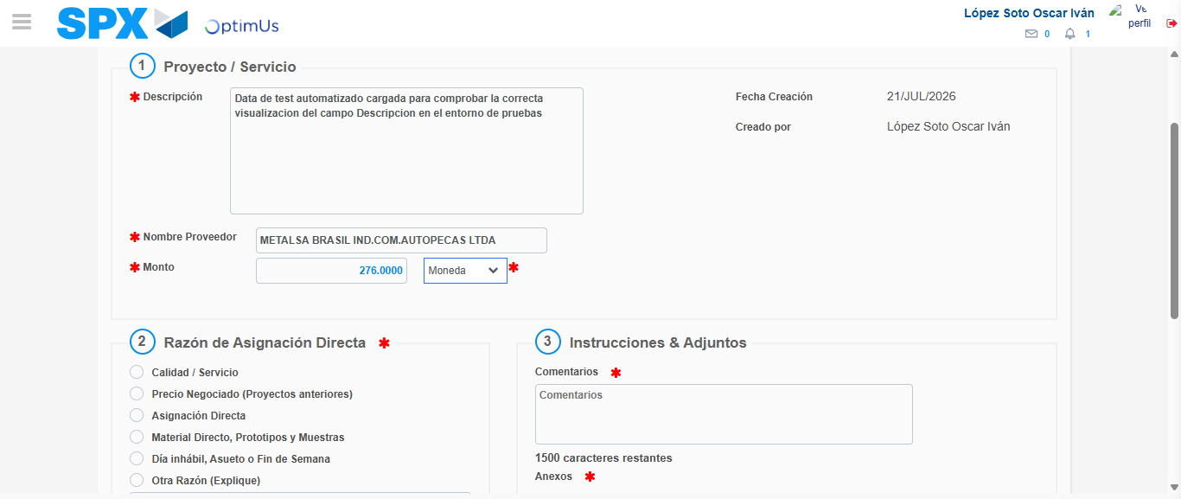Image file-name: QC_Testing-tc005_SPX_Dev5_Crear_Requisicion_Spot_Con_FAD_Tipo_Cobro_Project-1784652929199

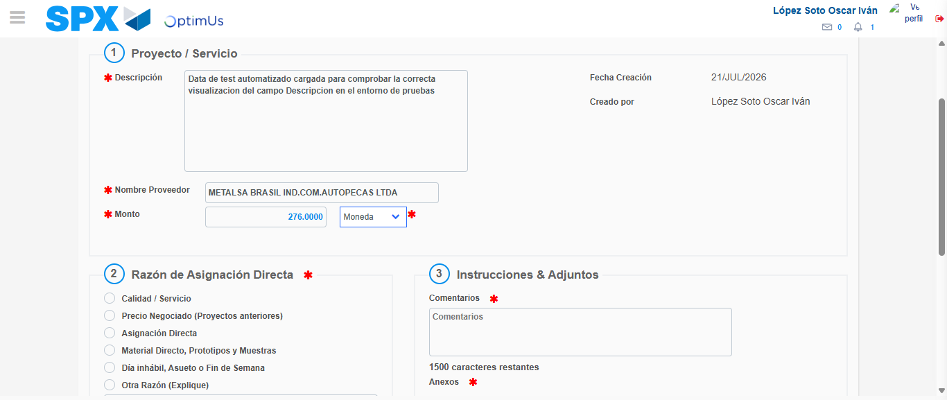Image file-name: QC_Testing-tc005_SPX_Dev5_Crear_Requisicion_Spot_Con_FAD_Tipo_Cobro_Project-1784652929425

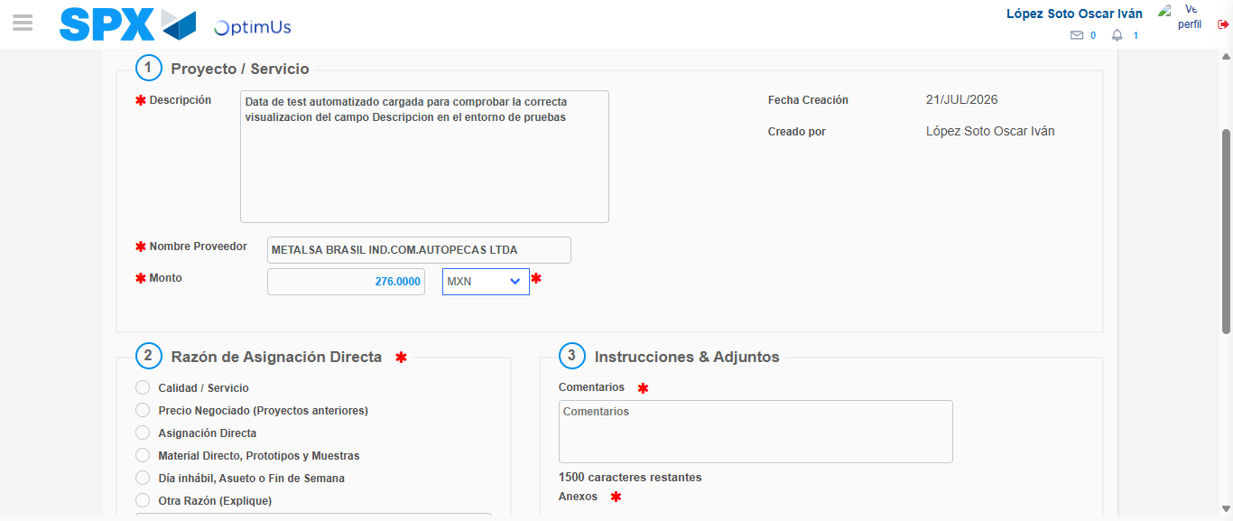Image file-name: QC_Testing-tc005_SPX_Dev5_Crear_Requisicion_Spot_Con_FAD_Tipo_Cobro_Project-1784652929971

Image file-name: QC_Testing-tc005_SPX_Dev5_Crear_Requisicion_Spot_Con_FAD_Tipo_Cobro_Project-1784652930223

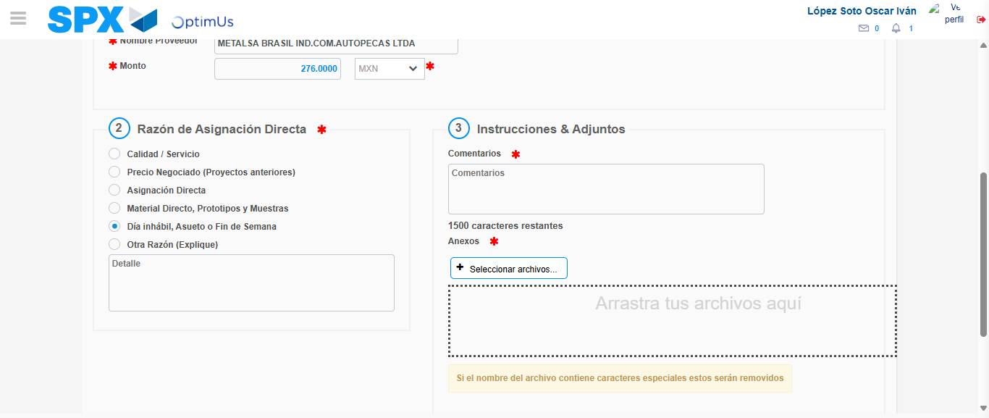Image file-name: QC_Testing-tc005_SPX_Dev5_Crear_Requisicion_Spot_Con_FAD_Tipo_Cobro_Project-1784652931241

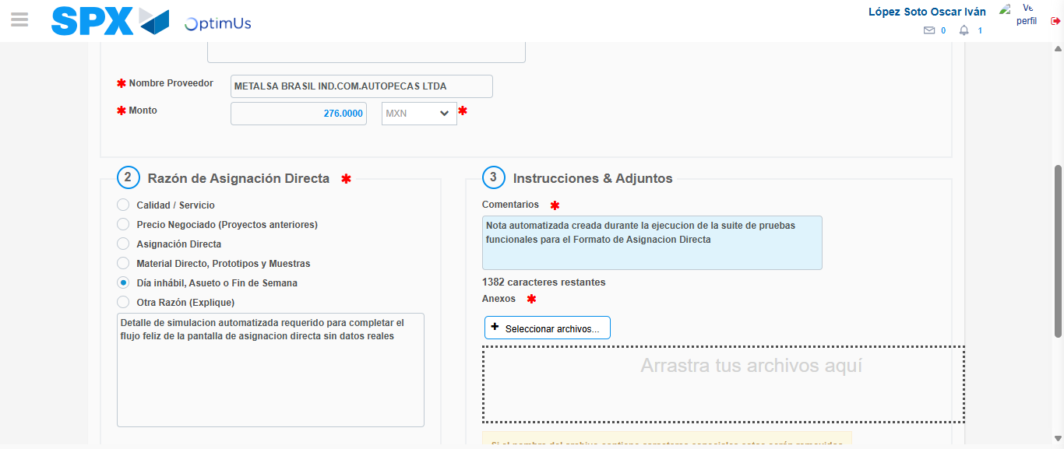Image file-name: QC_Testing-tc005_SPX_Dev5_Crear_Requisicion_Spot_Con_FAD_Tipo_Cobro_Project-1784652942756

Image file-name: QC_Testing-tc005_SPX_Dev5_Crear_Requisicion_Spot_Con_FAD_Tipo_Cobro_Project-1784652943631

Step 4 - Data Capture Spot Buy Requisition: Data captured correctly
Image file-name: QC_Testing-tc005_SPX_Dev5_Crear_Requisicion_Spot_Con_FAD_Tipo_Cobro_Project-1784652918536

Image file-name: QC_Testing-tc005_SPX_Dev5_Crear_Requisicion_Spot_Con_FAD_Tipo_Cobro_Project-1784652918738

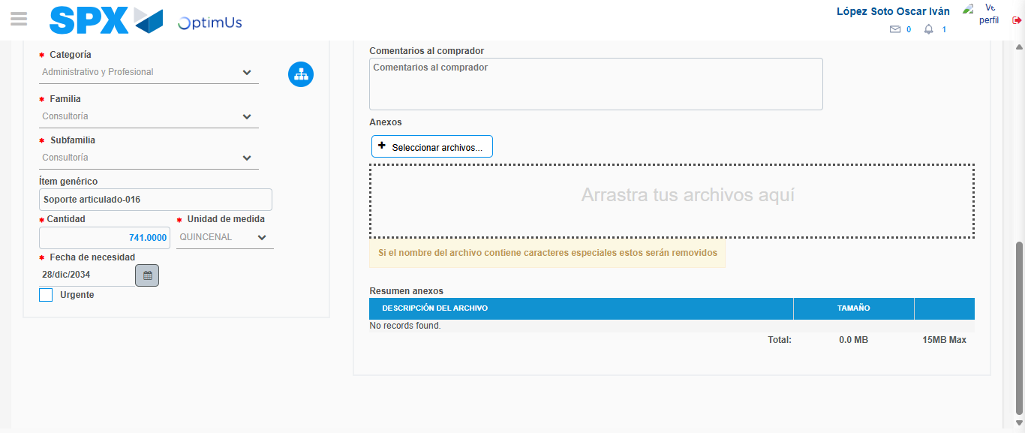Image file-name: QC_Testing-tc005_SPX_Dev5_Crear_Requisicion_Spot_Con_FAD_Tipo_Cobro_Project-1784652958390

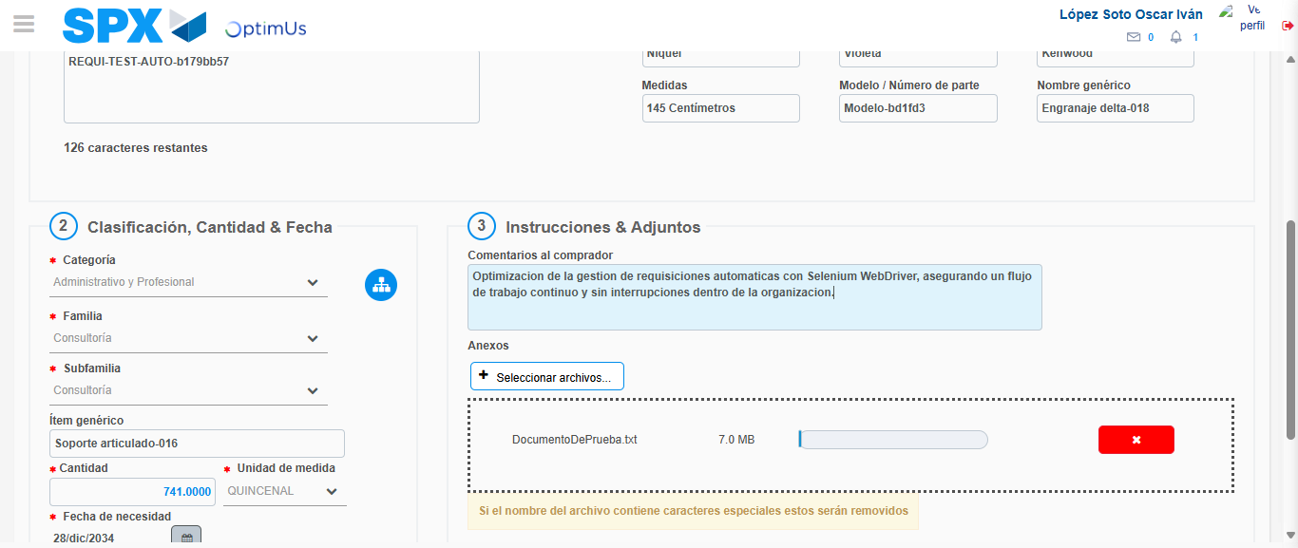Image file-name: QC_Testing-tc005_SPX_Dev5_Crear_Requisicion_Spot_Con_FAD_Tipo_Cobro_Project-1784652959417

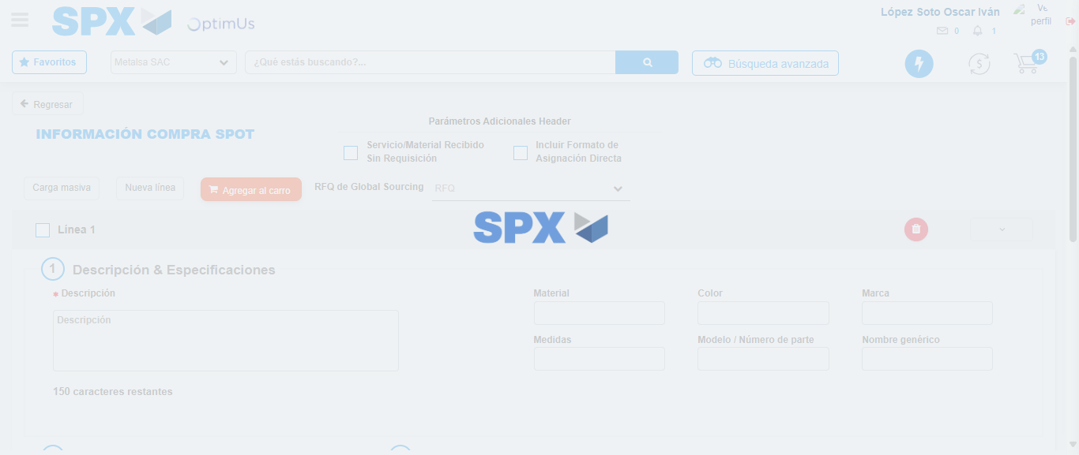Image file-name: QC_Testing-tc005_SPX_Dev5_Crear_Requisicion_Spot_Con_FAD_Tipo_Cobro_Project-1784652963543

Step 8 - Return to Main Page SPX : Return to Main Page SPX
Image file-name: QC_Testing-tc005_SPX_Dev5_Crear_Requisicion_Spot_Con_FAD_Tipo_Cobro_Project-1784652907986

Image file-name: QC_Testing-tc005_SPX_Dev5_Crear_Requisicion_Spot_Con_FAD_Tipo_Cobro_Project-1784652910732

Image file-name: QC_Testing-tc005_SPX_Dev5_Crear_Requisicion_Spot_Con_FAD_Tipo_Cobro_Project-1784652918197

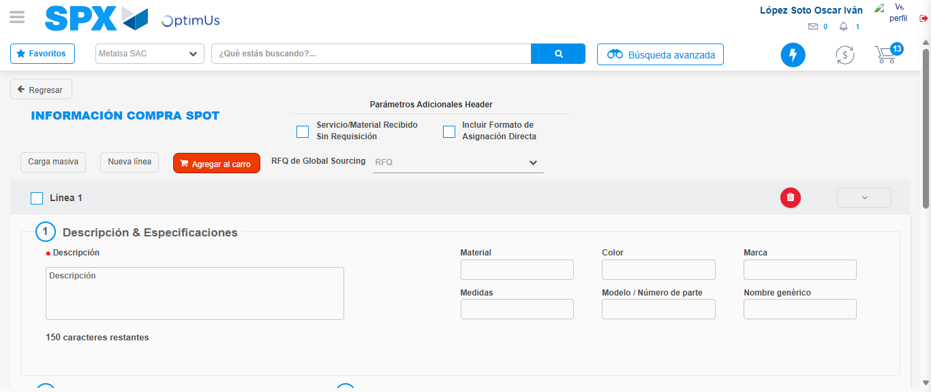Image file-name: QC_Testing-tc005_SPX_Dev5_Crear_Requisicion_Spot_Con_FAD_Tipo_Cobro_Project-1784652965817

Image file-name: QC_Testing-tc005_SPX_Dev5_Crear_Requisicion_Spot_Con_FAD_Tipo_Cobro_Project-1784652965987

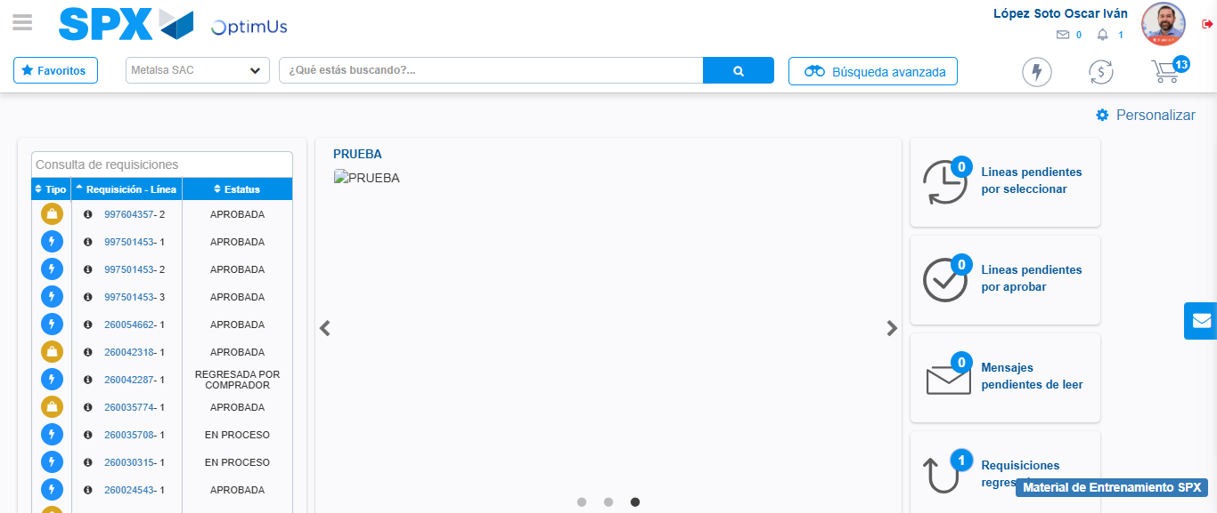Image file-name: QC_Testing-tc005_SPX_Dev5_Crear_Requisicion_Spot_Con_FAD_Tipo_Cobro_Project-1784652987313

Step 9 - Log Out : Log Out SPX
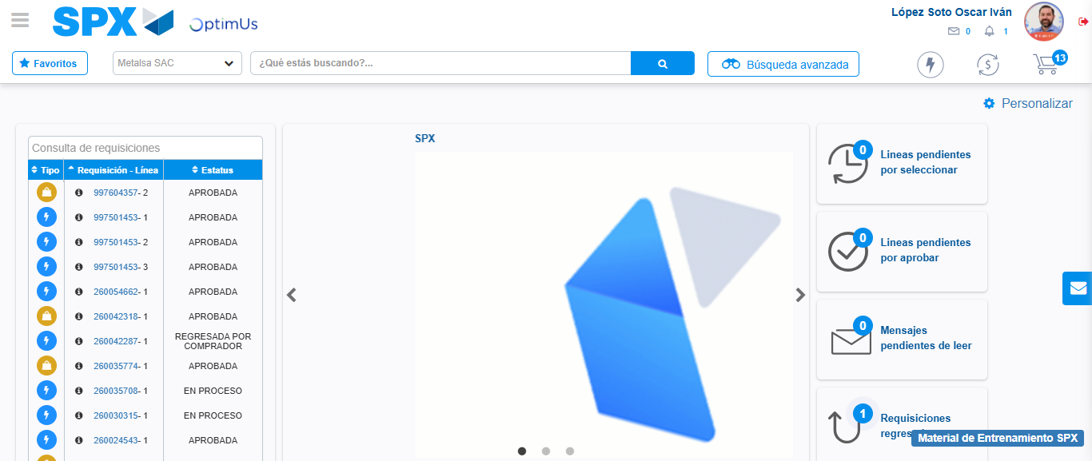Image file-name: QC_Testing-tc005_SPX_Dev5_Crear_Requisicion_Spot_Con_FAD_Tipo_Cobro_Project-1784652987706

